FAIR USE:
The ability to use copyrighted work without permission, but only in certain ways and in specific situations (schoolwork and education, news reporting, criticizing or commenting on something, and comedy/parody.

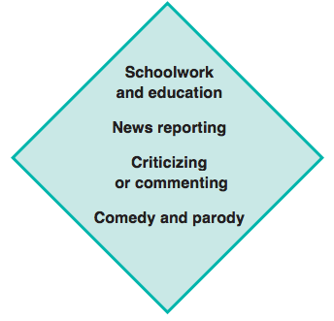
Use a small amount
Rework and use it in a different way
Add new meaning and make it original

Use for nonprofit purpose

